

**Alaska Indoor Gardening Curriculum**

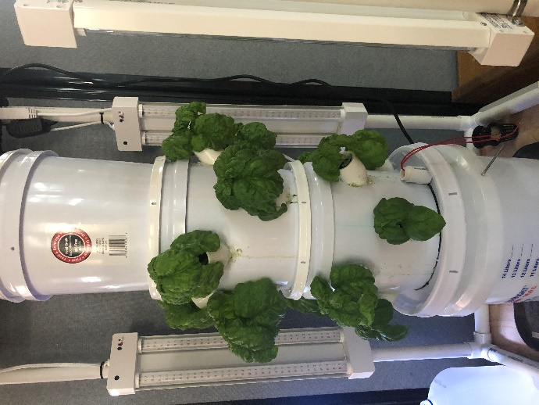**Small Grow Tower System Construction**

**Author/Source:** Mel Sikes, Adam Low (design)

**Suggested Grade Levels:** Upper Elementary, Middle, High School

*(Teachers can prep materials ahead of time.)*

**Time:** Multiple class periods

**Teaching Goal:**

To introduce students to the fun of raising edible plants indoors using a vertical hydroponic growing system made with hardware store buckets.

**Learning Objectives:**

To explore the plant life cycle by building and operating a hydroponic grow tower.

**Core Ideas:**

* Hydroponic Systems
* Plant Dynamics (circulation and nutrient uptake)
* pH, Acidity, and Alkalinity Testing
* Standardized Science Measurements
* Large Scale construction of a Hydroponic System
* Drawing Conclusions from Experimentation (hands-on, observation, and note-taking)

**Alaska State Science Standards: *Science:***4-LS1-1, 4-PS3-4, 5-PS3-1, 5-LS1-1, 5-LS2-1, MS-LS2-1, MS-LS2-4, MS-LS2-5, MS-ESS3-3, MS-ETS1-4, HS-LS1-2, HS-LS2-5, HS-ESS3-4

**NGSS Standards:** 4-LS1-1, 5-PS3-1, 5-LS1-1, 3-5-ETS1-1, MS-LS1-5, MS-LS2-1, MS-ESS3-3, MS-ETS1-4, HS-LS1-3, HS-LS2-7, HS-ESS2-6, HS-ESS2-7, HS-ESS3-4, HS-ETS1-3

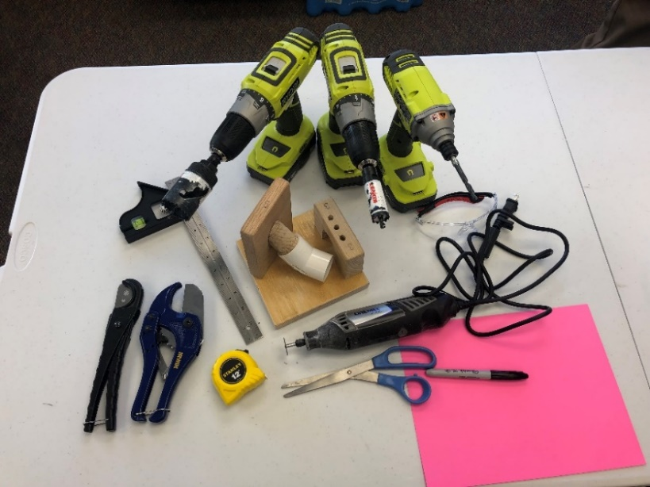**Tools Needed:**

* Drill (preferably cordless) (A)
* 1-5/8" Hole Saw Drill Bit

A– 5/20 Lot 66864

* Sharpie Marker
* Dremel Tool and Cutting Blades (B)
* PVC cutting tool (C)
* 7/8" Hole Saw Drill Bit
* Copies of the Stencils (end of directions)

B

* 1/4" Drill Bit

C

* Heavy Duty Scissors
* Ruler/Tape Measure
* **Protective Safety Eyewear for all!**

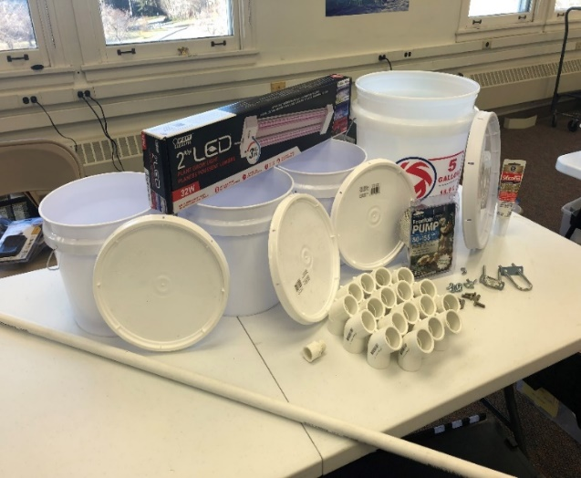**Materials Needed:**

* Three 2-Gallon Buckets
* One 5-Gallon Bucket
* One 5 Gallon Bucket Easy-Off Lid*
* Three 2-Gallon Bucket Easy-Off Lids*
* Four Foot length of 1/2" PVC straight PEX tubing
* Sixteen 1" 45° PVC Elbows
* 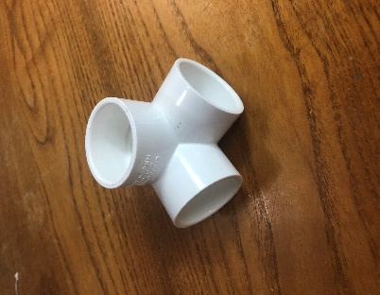158-200 GPH Submersible Water Pump
* A picture containing floor, indoor

  Description automatically generatedSix 1/4" x 1" Stainless Steel Hex Bolts
* Six 1/4" Stainless Steel Wing Nuts and washers
* Four 2 Ft. LED Light Fixture
* Hot Glue Gun and extra glue sticks
* PVC Glue or Plumber’s Silicone (optional or possibly necessary)
* Scrap piece of wood to drill on so you don’t ruin your table or floor.

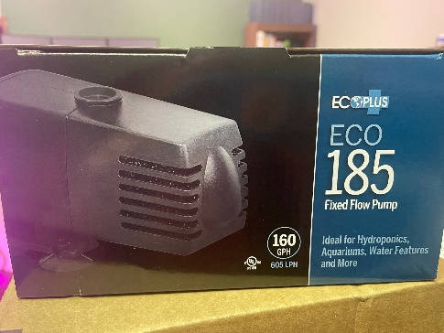**\* There are different types of bucket lids. Be sure to get the sturdiest lids you can find. It needs to hold the weight of the plants and the buckets.**

**Materials for Light Supporting Structure:**

* 1” PVC Pipe – 4 4’lengths and Eight 21 ½” lengths
* Logo

  Description automatically generated with medium confidenceEight 1" 90° PVC Three Way Elbow Sockets
* 2 2’x2’ pieces of plywood for top and bottom (Optional)
* Zip Ties or Small Screws for attaching the lights
* One 6 spot surge protector power strip
* Three Prong Outlet Timer

**Vocabulary:**

1. *Hydroponics:* is a method of growing plants in water without soil. The water must be enriched with nutrients and the plants need some type of inert medium to support the root system.
2. *Medium:* substance or material in which something exists or grows, from the soils and other materials for plant growth.
3. *pH:* stands for potential of hydrogen, which is a measurement of the hydrogen ion concentration in the water. Plants grow best in a slightly acidic pH range of 6 to 7.
4. *Acidity:* the level of acid in substances such as water, or soil
5. *Alkalinity:* the ability of water to neutralize acid or to absorb hydrogen ions.
6. *Algae:* algae is an informal term for a large diverse group of photosynthetic organisms which are not necessarily closely related
7. *Roots:* are a very important part of the plant, a roots four major functions are: absorption of water and inorganic nutrients, anchoring the plant, storage of food and nutrients and vegetative reproduction
8. *Oxygen:* plants take in oxygen and give off carbon dioxide nutrients
9. *Nutrients:* plants must obtain the following mineral nutrients for their growing medium they need nitrogen, phosphorus, potassium, calcium, sulfur, and magnesium

**Background for Teachers:**

The 'Do It Yourself' (DIY) Grow Tower Project is the brainchild of Alaskan entrepreneur Bernie Karl and Jake Scott. It is much more than just an experiment with vertical hydroponics, it is a concept meant to spark the curiosity of the youth all over the country - To help sow the seeds that will yield the next generation of farmers and food suppliers in America.

In order to cultivate a genuine passion for food production, one must first be introduced to it in a hands-on manner. That is the true purpose of the Lettuce Tower Project - An easy-to-build project that can get our youth involved in the construction and use of a hydroponic food production system.

This lesson plan is for a modified version of a larger 5 bucket tower that uses 5-gallon buckets for the tower and a sump basin as the bottom. This smaller version was designed by the Upward Bound Program at the University of Alaska Fairbanks.

The basic structure of the Grow Tower can be built almost entirely with supplies from your local hardware store, it fits into a 2x3-foot space (including light structure).

The opportunities for STEM with students are great with this project. Allow the students to explore options of modifying the design to maximize the efficiency of growth for the plants you choose to grow. Lights and the type of nutrients you use can be variable and worthy of experimentation. Also, you can explore the opportunities of automation and monitoring with easily available robotic devices such as Raspberry Pie boards (additional lessons are forthcoming).

**Step 1:**

**Prepare the Buckets and the Plant Sites**

**Remove the handles from all buckets.**

**Step 2:**

**Number the 2 gallon buckets with the numbers 1-3 with a sharpie on the bottom.**

**\*\*\*\*Set aside #3…Don’t mark up this one! It is the top bucket and doesn’t get holes drilled in it.\*\*\*\***

**Step 3:**

**Mark the 2 gallon buckets for drilling using the Stencil A (found at the**

**end of these instructions) These holes will be for the plant sites.**

1. **Poke a hole in the template at the sites A, B and C with a pencil.**
2. **Fold up the dotted line on the template and lay the template flush with the lid of the top of the bucket and mark the three holes through the stencil with the sharpie.**
3. **Move the stencil over to match up hole A on the stencil to the spot you marked for hole C and repeat the marking until you have 8 spots marked on the bucket.**
4. **Repeat the marking for the second bucket. (Remember the 3rd bucket should not be marked)**

**Step 1: Prepare the drill with the 1 5/8” Hole Saw.**

**Drill the Plant Sites**

**Step 2: Cut out the plant sites on the 2 buckets using the 1-5/8” hole saw.**

Figure 1-h

**The plastic circle cut out will likely get caught in the drill bit. Use a screwdriver or pliers to remove it if needed.**

**Drilling and Installing the Elbows**

***Be sure to wear safety eyewear for all Power Tool steps, anyone nearby should wear safety eyewear also.***

**Step 1: Use the 1/4" Hole Saw Drill Bit and a vise to hold the elbow or use a jig like the one below for drilling the holes. Drill three holes into the top of each PVC elbow to allow water to reach the plant roots. Be sure to drill the 3 holes in the top of each PVC elbow as pictured below. Uniform placement of holes is not necessary as long as they are in a location that water falling from the top of the tower can drip through and they are not right up to the bend in the elbow. The holes should be positioned so that they are completely inside the bucket when the elbow is inserted. *Clear away any plastic debris.***

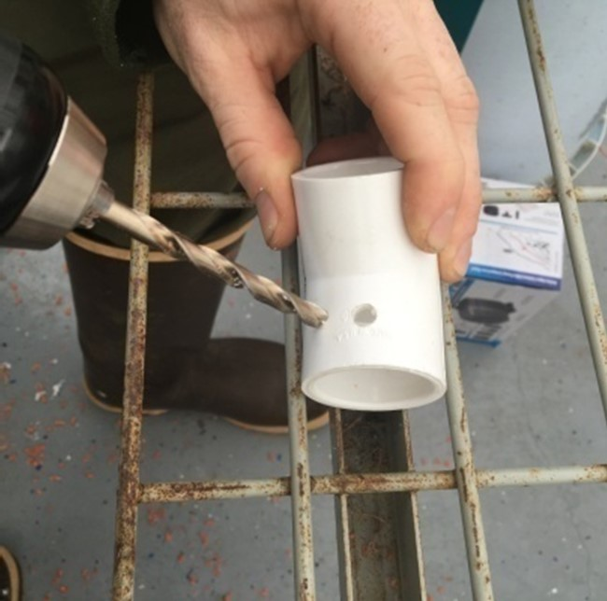

**of the holes on buckets #1 and #2 . *It will be a tight fit so be forceful.***

**Step 1: Now it's time to seal the elbows. Plug in the glue gun and have plenty of extra glue sticks handy.**

Figure 4-d

Figure 4-c

**Step 2: Using the glue gun, create a seal around each elbow to the bucket.** **Be sure to create an even seal around bottom and sides of the elbows. Be sure there is proper ventilation for fumes. Remove any hairy glue strings left after you finish.**

**Gluing the Elbows**

**Prepare the Bottoms of the 2 Gallon Buckets**

***Be sure to wear safety eyewear for all Power Tool steps,***

***anyone nearby should wear safety eyewear also.***

**Step 1: Prepare the Dremel Tools with a cutting blade.**

**Step 2: Mark the bottom of the 2 gallon buckets using the Stencil B (found**

**at the end of the instructions). Look for the circles in the center of the bucket bottoms. Flatten any dimples in the plastic in the middle of the circle using the Dremel tool*.***

**Step 3: Look for the circles in the center of the bucket bottoms. Flatten any dimples in the plastic in the middle of the circle using the Dremel tool*.***

**Step 4: Put the 7/8” Drill Bit on the Drill and drill a hole in the center of the**

**bucket bottom. The plastic circle cut out will get caught in the drill**

**bit. Use a screwdriver or pliers to remove this happens.**

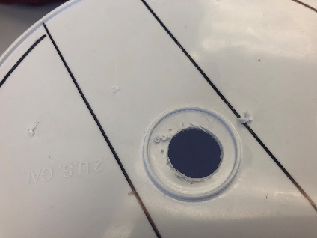

**Step 5: Using the Dremel, cut away two large sections leaving just a strip of plastic where the water line and bolt holes are situated.**

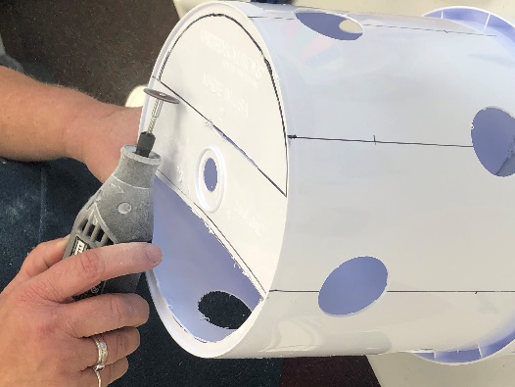

**Repeat Steps 3-5 for all the 2-gallon buckets including the top one which doesn’t have plant sites.**

**Prepare the Lids of the 2 Gallon Buckets**

***Be sure to wear safety eyewear for all Power Tool steps,***

***anyone nearby should wear safety eyewear also.***

**2 Gallon Lids**

**Step 1: Set one 2 gallon lid aside, this is the top lid and will not have holes.**

**Step 2: Mark two of the 2-gallon bucket lids using Stencil C.**

**Step 3: Prepare the drill with 7/8” hole saw. Using the drill and the 7/8" hole saw, cut a hole for the water line in the center of the 2 bucket lids. Repeat for the second lid.**

Fig. 2-h

Fig. 2-g

**Step 4: Remove the hole saw and put the ¼” drill bit on the drill. Create the drainage holes the bucket lids using the 1/4" drill bit. Do this for both of the lids.**

**Step 5: Lay the lid on top of the bottom of the bucket. Use the sharpie to**

**mark the hex bolt spot on the bottom of the bucket through the lid. Drill the two symmetrical holes on the bottom of the bucket. Make sure the holes line up. Connect the two with hex bolts, wing nuts or regular nuts and washers (if desired).**

**Step 6: Connect the two with hex bolts, wing nuts or regular nuts (and**

**washers if desired).**

**Prepare the Lid of the 5 Gallon Bucket**

***Be sure to wear safety eyewear for all Power Tool steps,***

***anyone nearby should wear safety eyewear also.***

**Step 1: Cut the center hole out of Stencil C and place in the center of the 5-gallon lid and use a sharpie to mark the circumference and the center hole.**

**Step2: Using the ¼ inch drill bit, Drill drainage holes in the 5-gallon lid through the paper of the stencil. *Be sure to drill on a piece of wood so you don’t damage the table you’re working on.***

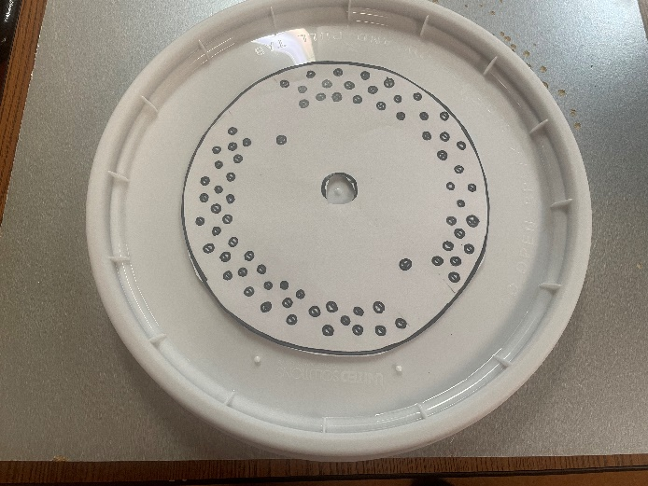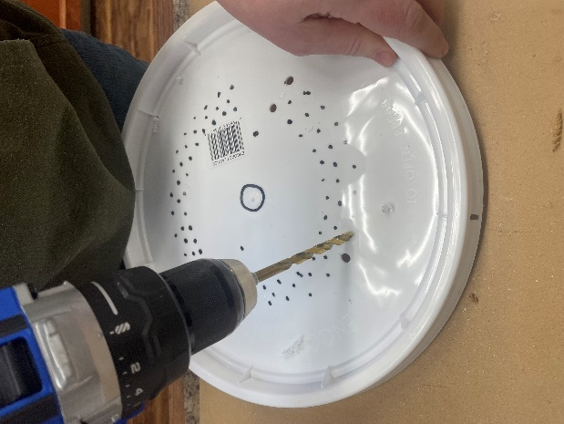

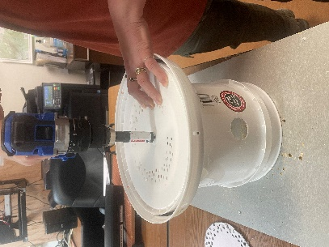

**Step 4: Using the 7/8” hole saw, drill the center**

**hole through both the lid and the 2 gallon**

**bucket bottom.**

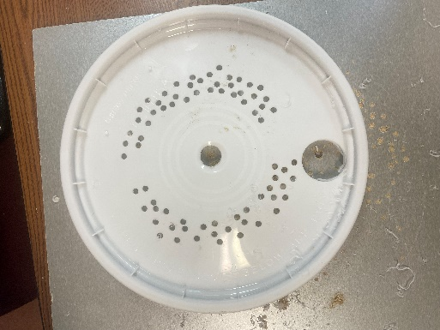

**Step 5: Use the 1 5/8” hole saw to cut a hole in the 5-**

**gallon lid for the electric cord for the pump.**

**Make sure this hole is not in line with the**

**center hole.**

**Step 6: Lay the bucket lid on top of the bottom of the 2-gallon bucket *(one with plant sites)*. Drill two holes through the lid and bottom of the 2-gallon bucket to have these holes line up perfectly. Clear away all plastic debris.**

**Step 7: Bolt the lid to the bottom the 2-gallon bucket.**

**Step 1: Connect the threaded male PVC adapter that comes with the pump to one end of the 4ft length of ½ ” PVC pipe. You can use the red washers that come in the pump package to give it a tight fit. If it is still loose, add some PVC or marine glue and let it dry before finishing assembly.**

**Set up the Water Line and Assemble the Tower**

**Step 2: Place the pump in the bottom of the 5 gallon bucket and screw in the PVC pipe.**

**Step 3: Slide the tower base assembly down the pipe and feed the pump cord through the hole you drilled for it.**

**Step 4: Stack your buckets in the order that they are numbered and firmly**

**snap each lid to the top of the next bucket. Add a funnel to the top**

**bucket on the pipe to help distribute the water evenly to the sides. Trim pipe with the PVC cutter to be flush with the top of the funnel. Put on the top bucket lid.**

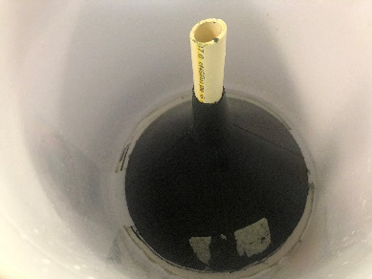

**Building the Light Structure**

**Step 1: Cut four 4 foot lengths of 1” PVC pipe using the PVC cutter.**

**Step 2: Cut eight 2 foot lengths of 1” PVC pipe**

**Step 3: Count out 8 three way PVC elbows.**

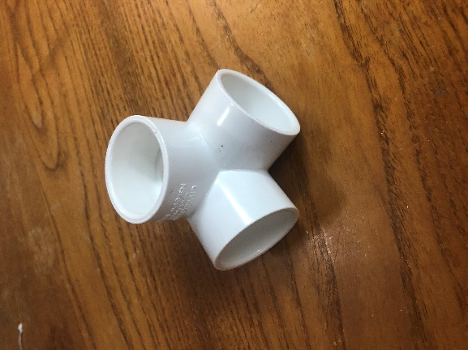

**Step 4: Attach 2 elbows to each of the four foot PVC Pipes.**

**Step 5: Add a 2 ft pipe to one of the 4ft pipes. Connect to another 4 foot**

**pipe.**

**Step 6: Continue connecting all the pipes until your structure looks like this:**

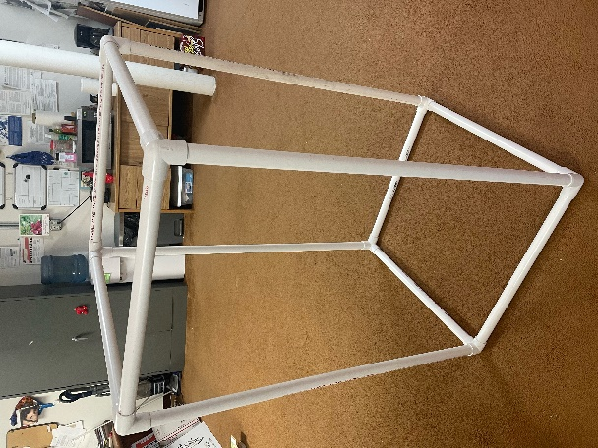

**Step 7: Attach the lights to the 4 foot pipes with zip ties and the light holders that come with the lights. You can also screw them directly into the PVC with the screws that come with the lights.**

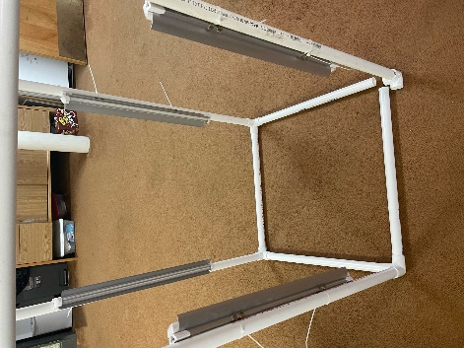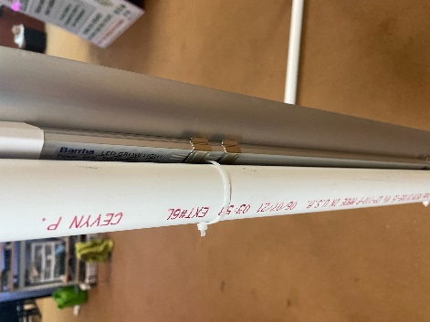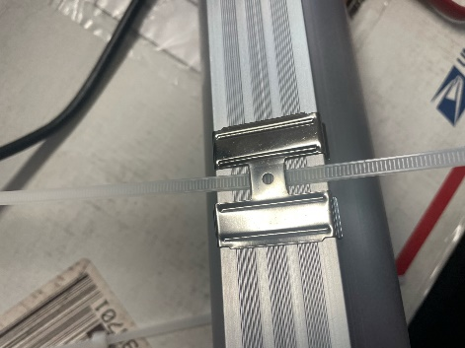

**Extensions:**  Suggested Lessons: Intro to Hydroponics, Hydroponic Plant Growth, Journaling lesson, Indoor Gardening, Passive Hydroponic System.

**Assessment:** Students can explain how the system works. Successful plant growth.

**References**

**Books:**

*Gardening Indoors with Soil and Hydroponics*

by George Van Patten 2007 ISBN: 978-1-878823-32-8

*How to Hydroponics*by Kenneth Roberto

ISBN: 0-9672026-1-2 2014

*Hydroponic Basics: The Basics of Soilless Gardening Indoors*

by*George F. Van Patton 2004 ISBN: 978-1-878823-25-0*

*Hydroponics: A Complete DIY Guide for Gardening Using Simple Steps*

by Allen Dunn 2012 ISBN: 9781480236141

*Vertical Gardening: Grow Up, Not Out, For More Vegetables and Flowers in Much Less Space*

by Derek Fell 2011 ISBN: 978-1-60529-083-6

*Vertical Gardening for Beginners: How to Grow Organic Food at Home Without a Yard*

*by*PeterKingston 2016 ISBN: 9781532804823

**Websites:**

*Chena Hot Springs Resort:*<https://chenahotsprings.com/vertical-bucket-grow-tower/>

*Foothill Hydroponics:* <http://www.foothillhydroponics.com/>

*General Hydroponics:* <http://generalhydroponics.com/>

*Hydroponics:* <https://hydroponics.com/>

*Institute of Simplified Hydroponics:* <http://carbon.org/>

Simply Hydroponics and Organics: <http://www.simplyhydro.com/system.htm>

*Uponics***:** <http://uponics.com/hydroponic-tower/>



